🌱 Spring IoC, ApplicationContext & BeanFactory – Detailed Notes

1️⃣ What is Spring IoC (Inversion of Control)?
🔍 Definition
IoC (Inversion of Control) means:
Spring controls object creation and dependency management instead of the programmer
Earlier:
- YOU created objects using new
- YOU managed dependencies
Now:
- Spring creates objects
- Spring injects dependencies
- You only define configuration

❌ Before IoC (Traditional Java)
class OrderService {
PaymentService paymentService = new PaymentService(); // tightly coupled
}
Problems:
- ❌ Tight coupling
- ❌ Hard to test
- ❌ Hard to replace implementation
- ❌ Not flexible

✅ After IoC (Spring Way)
class OrderService {
private PaymentService paymentService;

public OrderService(PaymentService paymentService) {
this.paymentService = paymentService;
}
}
✔ Spring injects PaymentService
✔ Loose coupling
✔ Easy to test
✔ Flexible & maintainable

🧠 Why is it called Inversion of Control?
Traditional Java | Spring IoC
Developer controls object creation | Spring controls object creation
new keyword everywhere | No new keyword
Code decides dependencies | Container decides dependencies
👉 Control is inverted from developer → framework

2️⃣ What is Spring IoC Container?
🔍 Definition
The IoC Container is the heart of Spring.
It:
- Creates objects (beans)
- Injects dependencies
- Manages lifecycle
- Destroys objects
📦 Objects created by Spring are called Beans

🏗️ Spring IoC Architecture
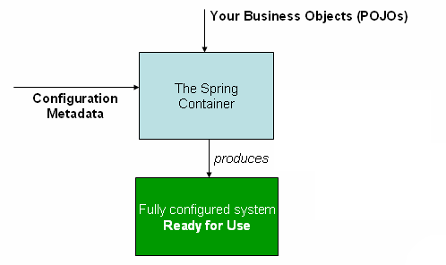

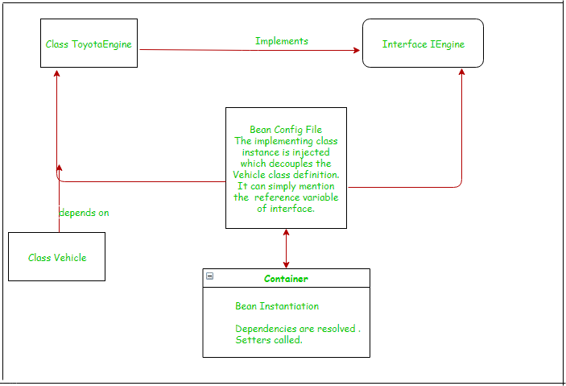
Flow:
Configuration → IoC Container → Beans → Application

3️⃣ What is a Bean in Spring?
🔍 Definition
A Bean is:
An object created, configured, and managed by Spring IoC container
Example:
@Component
class PaymentService {
}
✔ Spring creates this object
✔ Spring manages lifecycle

4️⃣ BeanFactory
🔍 What is BeanFactory?
BeanFactory is the simplest IoC container in Spring.
📦 Package:
org.springframework.beans.factory.BeanFactory

🧠 Why BeanFactory?
- Lightweight
- Suitable for simple applications
- Used mainly in memory-constrained environments

⚙️ How BeanFactory Works
- Beans are created ONLY when requested
- This is called Lazy Initialization
PaymentService ps = factory.getBean("paymentService");
Bean created at this line, not before.

🧪 Example using BeanFactory
Resource resource = new ClassPathResource("beans.xml");
BeanFactory factory = new XmlBeanFactory(resource);

PaymentService payment = (PaymentService) factory.getBean("paymentService");
payment.pay();
📌 Bean created only when getBean() is called

❌ Limitations of BeanFactory
- No AOP support by default
- No event handling
- No internationalization (i18n)
- Manual configuration heavy

5️⃣ ApplicationContext
🔍 What is ApplicationContext?
ApplicationContext is an advanced, enterprise-level IoC container.
📦 Package:
org.springframework.context.ApplicationContext

🧠 Why ApplicationContext?
Because it provides:
- Dependency Injection
- AOP
- Event handling
- Internationalization
- Auto bean creation
- Annotation support
👉 99% of Spring applications use ApplicationContext

⚙️ How ApplicationContext Works
- Beans are created at startup
- This is called Eager Initialization
ApplicationContext context =
new ClassPathXmlApplicationContext("beans.xml");
✔ All beans created immediately
✔ Errors detected early

🧪 Example using ApplicationContext
Step 1: Bean class
public class PaymentService {
public void pay() {
System.out.println("Payment Successful");
}
}

Step 2: XML Configuration
<beans>
<bean id="paymentService" class="com.example.PaymentService"/>
</beans>

Step 3: Main class
ApplicationContext context =
new ClassPathXmlApplicationContext("beans.xml");

PaymentService payment =
context.getBean(PaymentService.class);

payment.pay();
✔ Object created by Spring
✔ Dependency managed by container

6️⃣ BeanFactory vs ApplicationContext
Feature | BeanFactory | ApplicationContext
Initialization | Lazy | Eager
Performance | Lightweight | Slightly heavier
AOP | ❌ No | ✅ Yes
Events | ❌ No | ✅ Yes
i18n | ❌ No | ✅ Yes
Annotation support | Limited | Full
Enterprise ready | ❌ No | ✅ Yes

7️⃣ Real-World Example (Easy to Remember)
🍕 Pizza Shop Analogy
❌ Without IoC:
Customer goes to kitchen, prepares pizza
✅ With IoC:
Customer orders → Kitchen prepares pizza
Role | Real World | Spring
Kitchen | Controls cooking | IoC Container
Pizza | Food | Bean
Customer | Uses pizza | Application
👉 Customer doesn’t care how pizza is made

8️⃣ How IoC Works Internally (Step-by-Step)
Controller → Service → DAO → Logic
- Spring reads configuration
- Creates beans
- Resolves dependencies
- Injects dependencies
- Manages lifecycle

9️⃣ Why IoC is VERY IMPORTANT?
✔ Loose coupling
✔ Testable code
✔ Easy maintenance
✔ Enterprise ready
✔ Supports AOP & Transactions

🔑 Final Summary (Exam / Interview Ready)
- IoC = Spring controls object creation
- Bean = Object managed by Spring
- BeanFactory = Basic, lazy, lightweight
- ApplicationContext = Advanced, eager, enterprise
- ApplicationContext is preferred

